CS 470 Project One Guide

APIs to Lambda

- Be careful with the case of the API resources. REST is a case-sensitive protocol, and the wrong case will prevent your application from working correctly.
- After every API mapping to a Lambda, you will be asked to approve the addition to the permission of the Lambda. Click OK. This permission allows each API you map to a Lambda access to that specific Lambda.

Part One: The Questions API

- Navigate to the API Gateway in the AWS console. See Module Four Assignment Two for a refresher.
- Click the orange Create API button, then click Build on the REST API menu.
  - Do not click the REST API marked private.

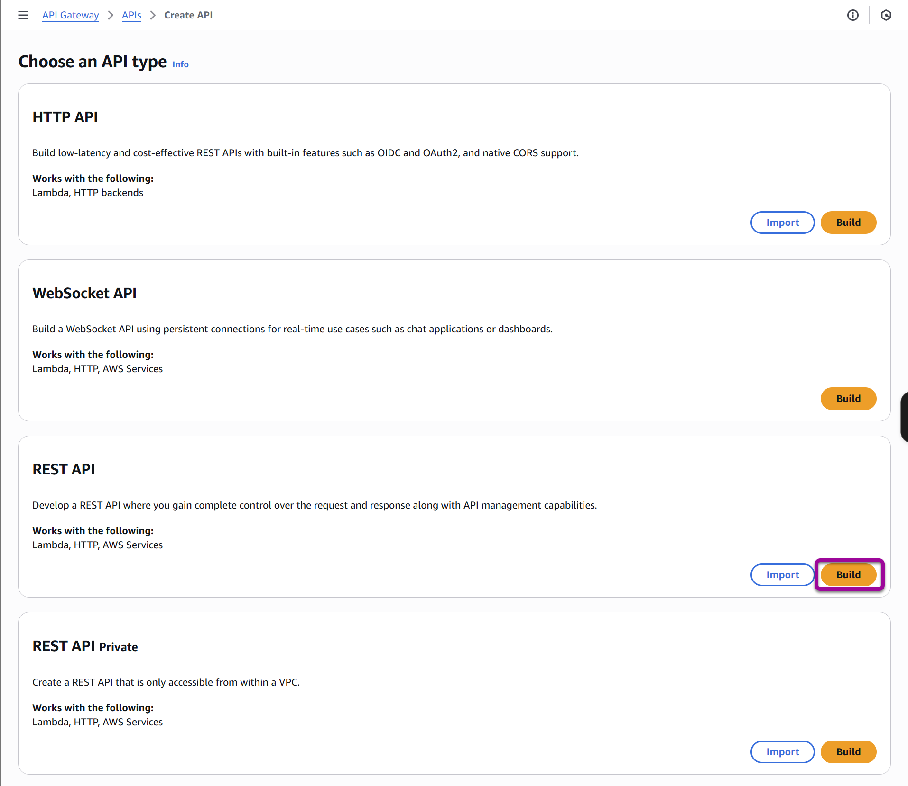

- Your settings should be REST, New API, an API name “Questions & Answers”, and a Security policy of SecurityPolicy_TLS13_1_3_2025_09 (recommended).
Note: the available security policy numbers may change, select the version with the latest date as applicable.

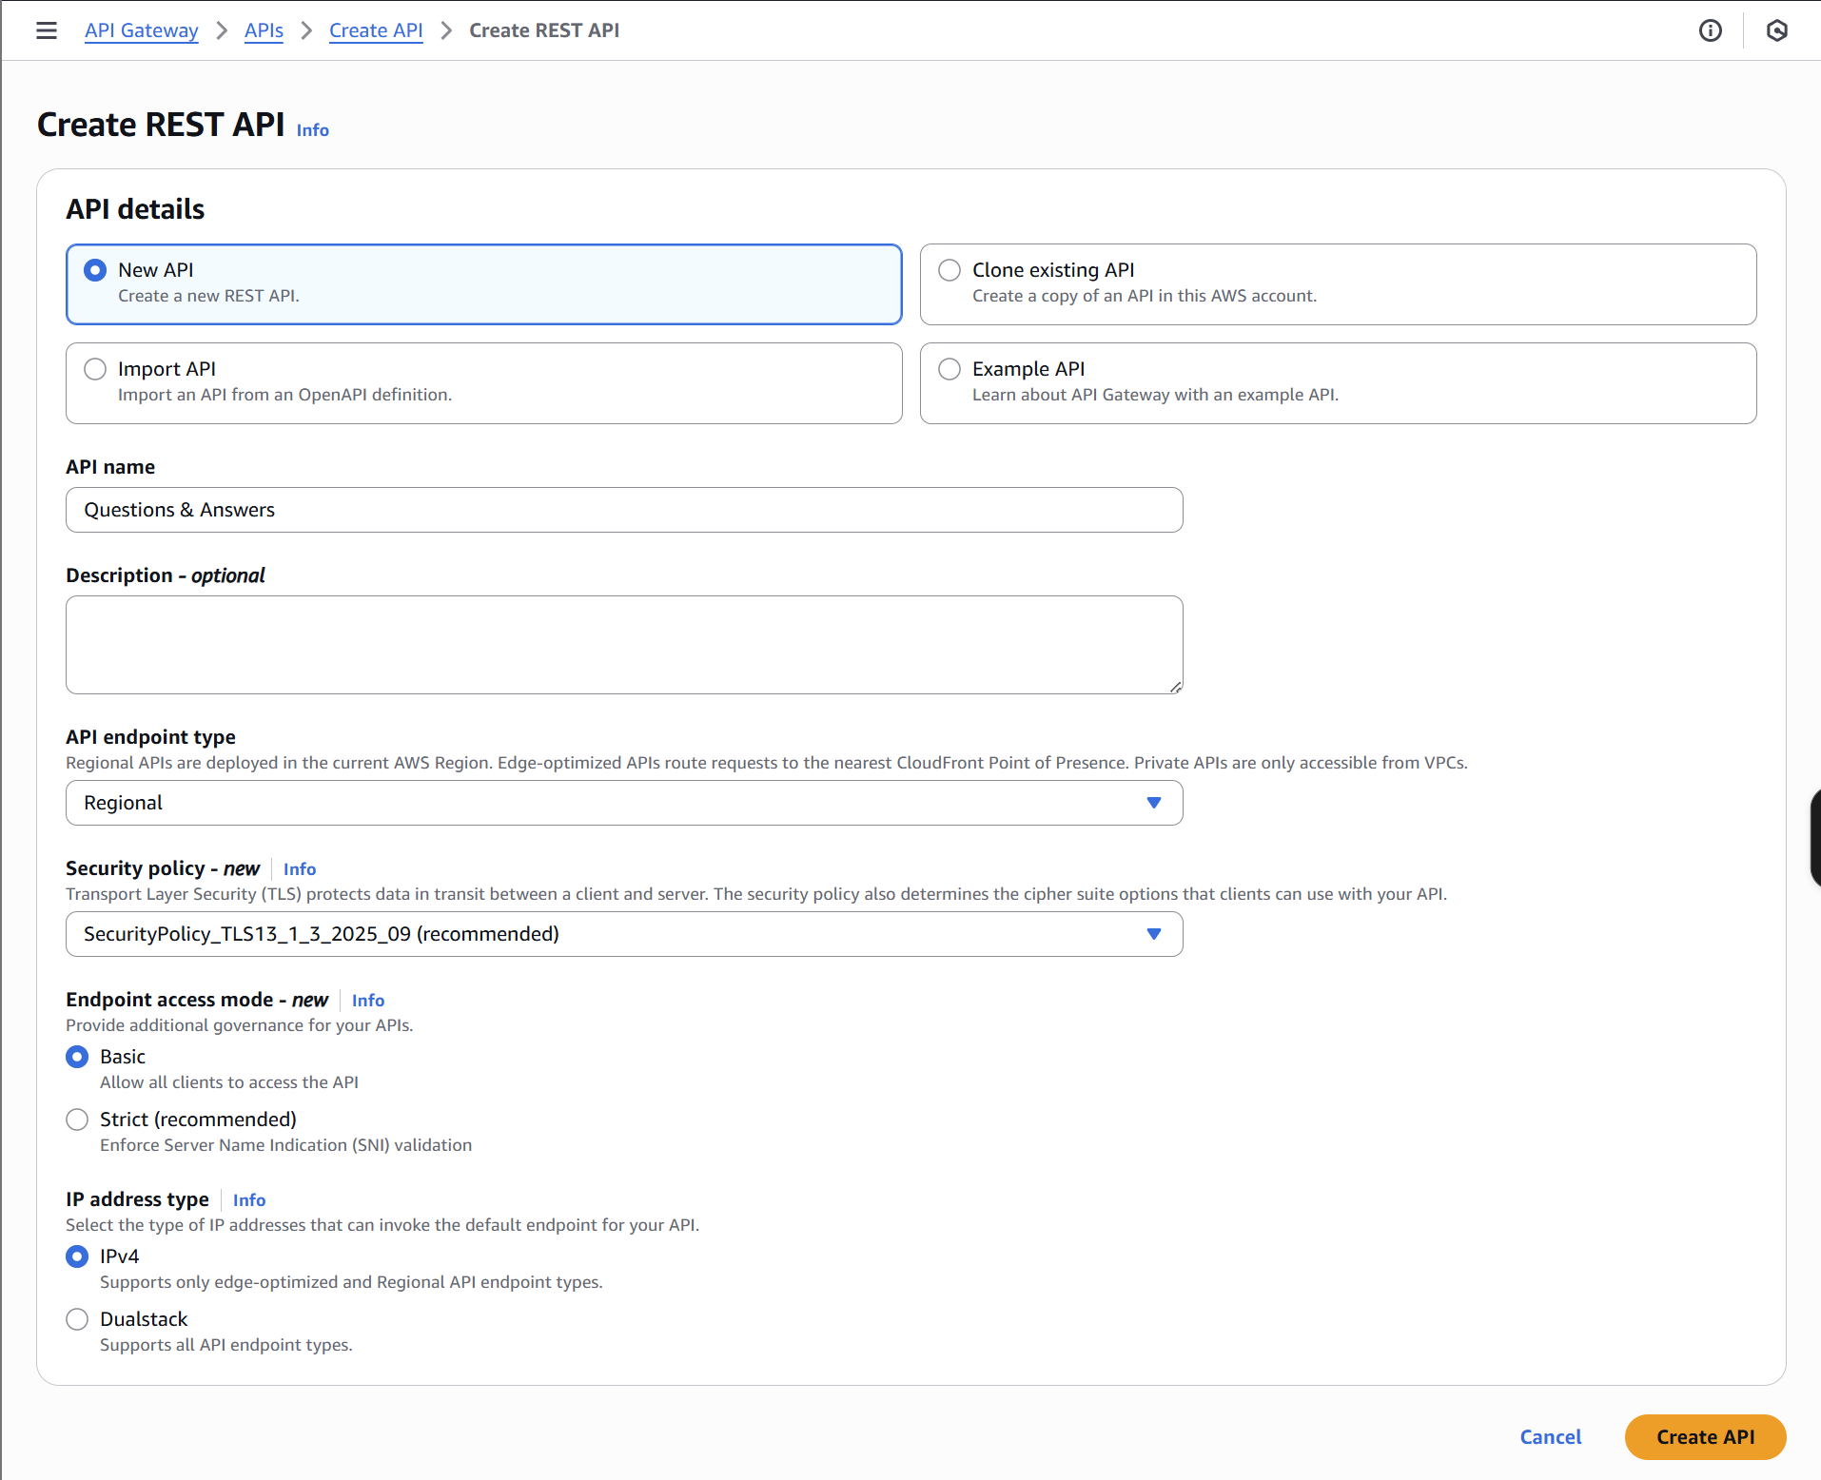

- Leave all other settings at the default, click the Create API button.

Questions Resource

- Click Create Resource on the left side under the Resources page title.
- Create a resource named “Questions”, and make certain the resource name has a capitalized Q.
- Leave the check boxes unchecked and click Create Resource.
- With /Questions selected, click Create Method on the top of the Methods menu on the right side.

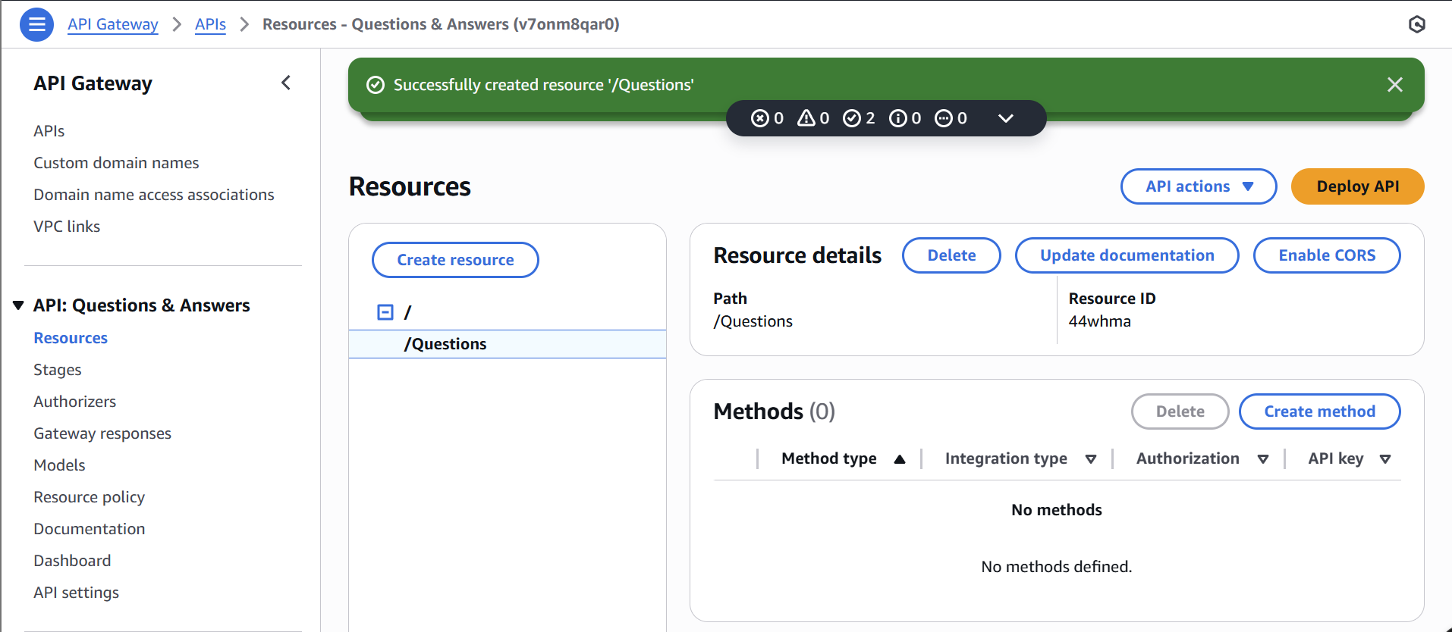

- Select the GET method in the Method type drop-down box.
- Make certain Lambda Function and Lambda Proxy Integration are selected. Use region us-east-1 with the Lambda function TableScan.

Note: Do not modify the Method request settings Authorization field; setting the value to AWS IAM will break your application CORS functionality later, leave it to none for all methods in the project. Confirm that your Lambda proxy integration is enabled for all methods or your application will not process the request correctly later in the Project.

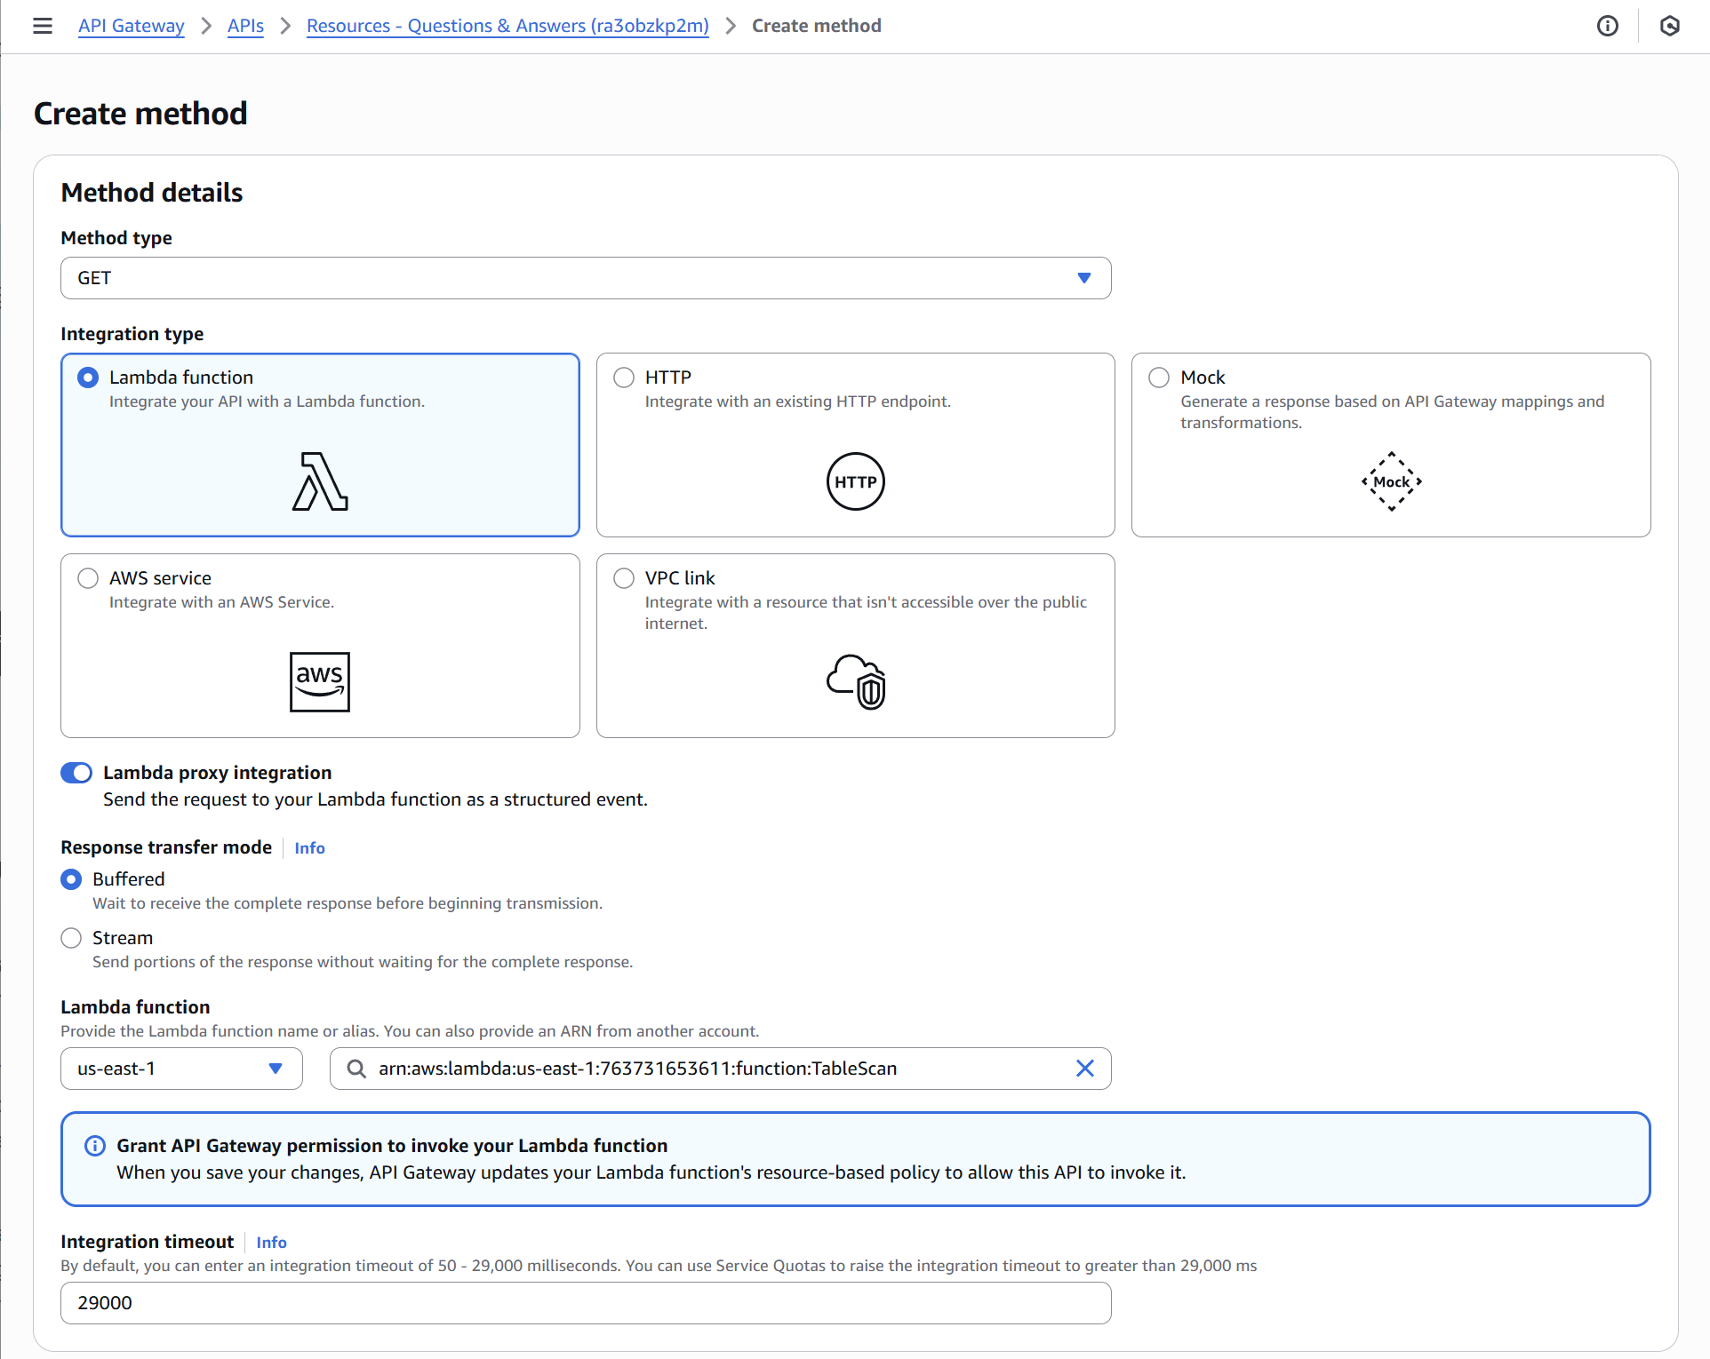

- Click the Create method button.
- Add the POST method to Questions with the following setup:

  - Integration type: Lambda Function
  - Use Lambda Proxy Integration: Checked
  - Lambda region: us-east-1
  - Lambda Function: UpsertQuestion

- Add the PUT method to Questions with the following setup:

  - Integration type: Lambda Function
  - Use Lambda Proxy Integration: Checked
  - Lambda region: us-east-1
  - Lambda Function: UpsertQuestion

The {id} Sub-Resource

- Select the /Questions resource and click Create Resource above it.
- Create a resource named “{id}”. Pay attention to the resource path. It should be /Questions/{id}. Leave CORS unchecked.
- Click the Create method button with /{id} selected.
- Add a GET method to /Questions/{id} with the following setup:

  - Integration type: Lambda Function
  - Use Lambda Proxy Integration: Checked
  - Lambda region: us-east-1
  - Lambda Function: GetSingleRecord

- Add a DELETE method to /Questions/{id} with the following setup:

  - Integration type: Lambda Function
  - Use Lambda Proxy Integration: Checked
  - Lambda region: us-east-1
  - Lambda Function: DeleteRecord

- Add a PUT method to /Questions/{id} with the following setup:

- Integration type: Lambda Function
- Use Lambda Proxy Integration: Checked
- Lambda region: us-east-1
- Lambda Function: UpsertQuestion

The findOne Sub-Resource

- With /Questions selected, create a new resource named “findOne” under Questions. Pay attention to the casing of the resource name.

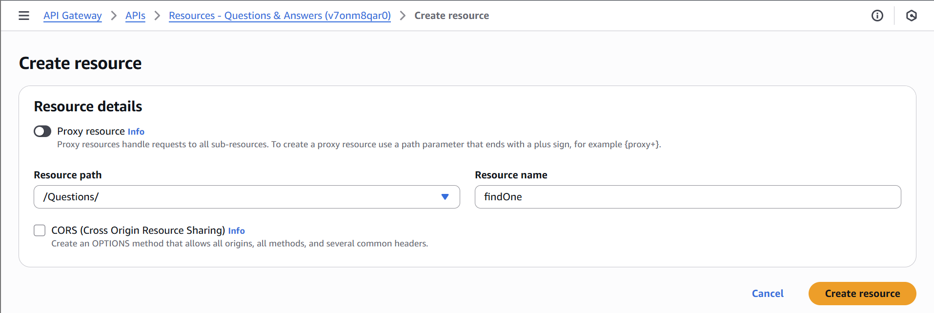

- Add a GET method to /Questions/findOne with the following setup:

- Integration type: Lambda Function
- Use Lambda Proxy Integration: Checked
- Lambda region: us-east-1
- Lambda Function: FindOneQuestion

Part Two: The Answers API

The Answers Resource

- Create a new top-level resource named “Answers”. Select the forward slash (/). Make certain the resource path is /Answers. Then click Create resource.
- Add a GET method to /Answers with the following setup:

- Integration type: Lambda Function
- Use Lambda Proxy Integration: Checked
- Lambda region: us-east-1
- Lambda Function: TableScan

- Add a POST method to /Answers with the following setup:

- Integration type: Lambda Function
- Use Lambda Proxy Integration: Checked
- Lambda region: us-east-1
- Lambda Function: UpsertAnswer

- Add a PUT method to /Answers with the following setup:

- Integration type: Lambda Function
- Use Lambda Proxy Integration: Checked
- Lambda region: us-east-1
- Lambda Function: UpsertAnswer

The {id} Sub-Resource

- Create an {id} resource under Answers. Make certain the Resource Path is /Answers/{id}.
- Add a GET method to /Answers/{id} with the following setup:

- Integration type: Lambda Function
- Use Lambda Proxy Integration: Checked
- Lambda region: us-east-1
- Lambda Function: GetSingleRecord

- Add a DELETE method to /Answers/{id} with the following setup:

- Integration type: Lambda Function
- Use Lambda Proxy Integration: Checked
- Lambda region: us-east-1
- Lambda Function: DeleteRecord

- Add a PUT method to /Answers/{id} with the following setup:

  - Integration type: Lambda Function
  - Use Lambda Proxy Integration: Checked
  - Lambda region: us-east-1
  - Lambda Function: UpsertAnswer

- You should now have an API Resources tree that looks like this:
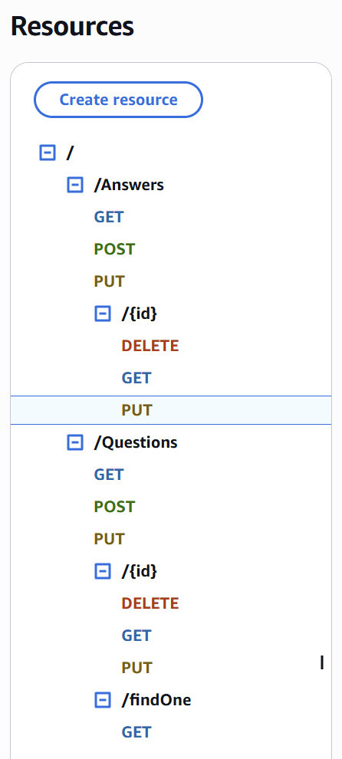

- Before proceeding to the CORS section, confirm that all your methods above have the Lambda proxy integration set to “True”. To do so, check the Integration request > Integration request settings page for each method.

Supporting CORS
Cross-origin resource sharing (CORS) is a mechanism that uses HTTP headers to allow resource sharing across different domains. AWS Gateway has an action to enable CORS, but you will not be using it. This action is only partially successful, so you will do this manually as defined on the CORS on AWS API Gateway website. The requirements are to have an OPTIONS method for each resource with specific headers returned and for some specific headers to be returned on each REST method called.

Adding CORS to Questions Resource

- Select the /Questions resource and add an OPTIONS method.
- Select Mock as the integration type and click the Create method button.
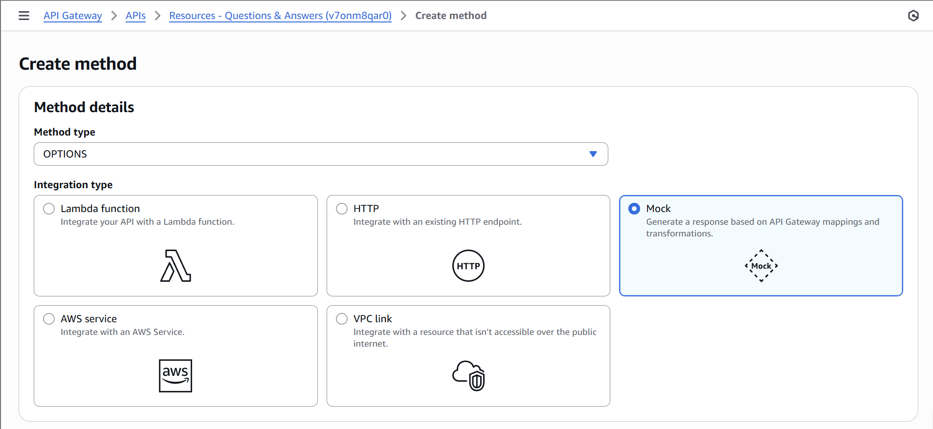

- Click the Method Response link.

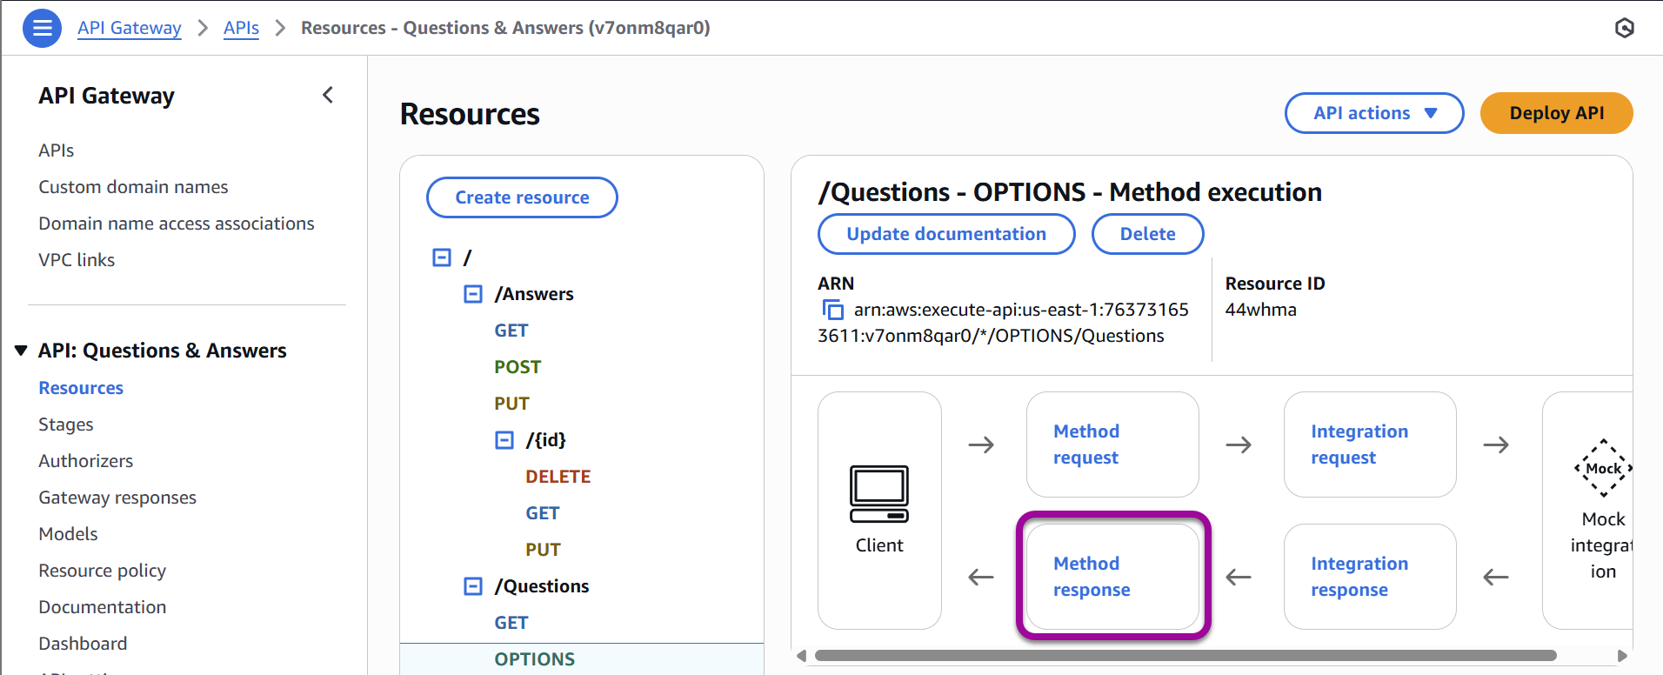

- You must now add some headers. Click Edit next to Response 200 and then click Add Header.
- Enter “X-Requested-With” in the box. Be careful to use the correct case and do not include spaces.
- Repeat the process to add the following Response headers:

  - Access-Control-Allow-Headers
  - Access-Control-Allow-Origin
  - Access-Control-Allow-Methods
  - Access-Control-Allow-Credentials

When complete, the Response Headers section will look like this:
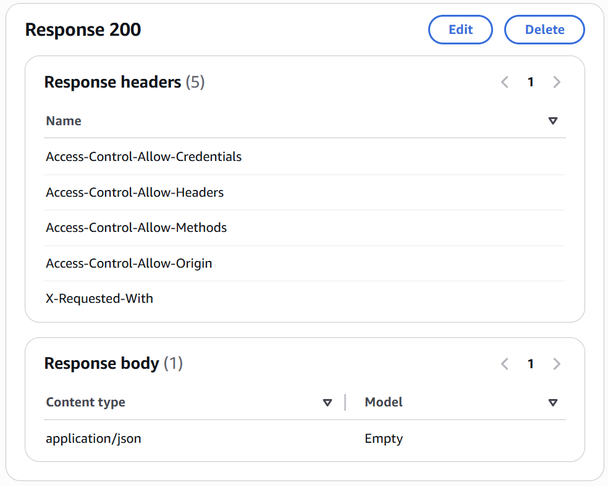

- Click the Integration Response link.
- Open the 200 method response status by clicking the Edit button next to Default - Response.
- Scroll down to the Header Mappings section.
- For X-Requested-With, enter '*', with the quotes.
- For Access-Control-Allow-Headers, enter 'Content-Type,X-Amz-Date,Authorization,X-Api-Key,x-requested-with', with the quotes.
- For Access-Control-Allow-Origin, enter '*', with the quotes.
- For Access-Control-Allow-Methods, enter 'OPTIONS,*', with the quotes.
- For Access-Control-Allow-Credentials, enter 'true', with the quotes.
- When done, the Header Mappings page should look like this:

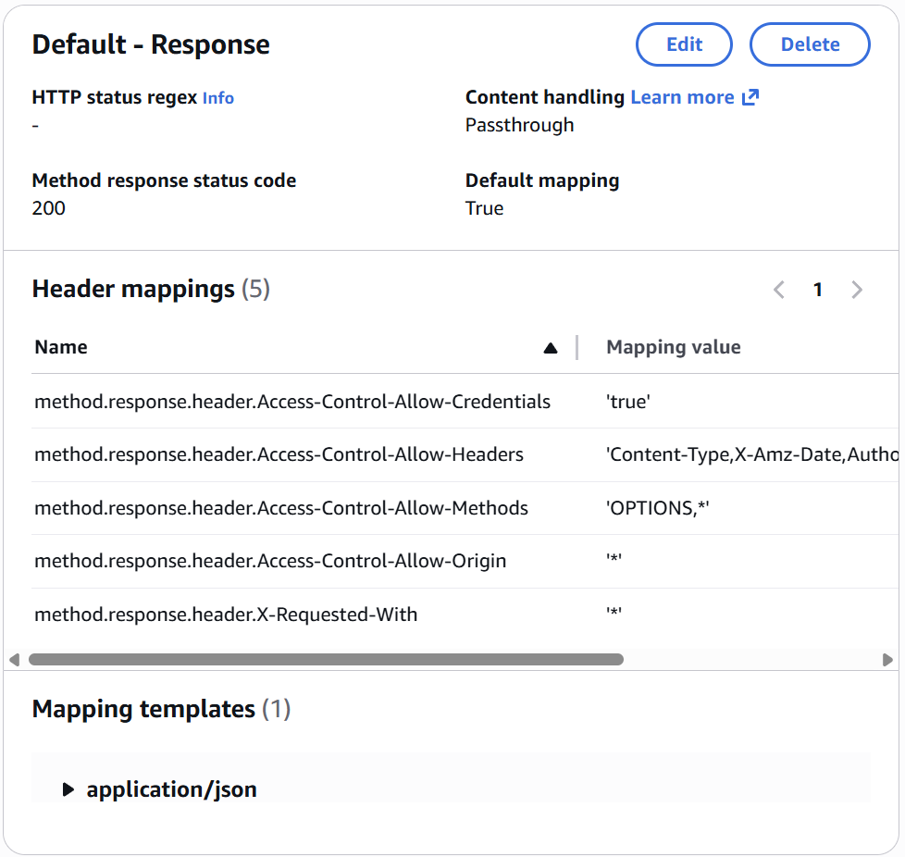

Adding CORS to the Remaining Resources

- Repeat this process for each resource and sub-resource to add the OPTIONS method with responses:

  - /Answers
  - /Answers/{id}
  - /Questions/findOne
  - /Questions/{id}

- When complete, your Resources tree will look like this:

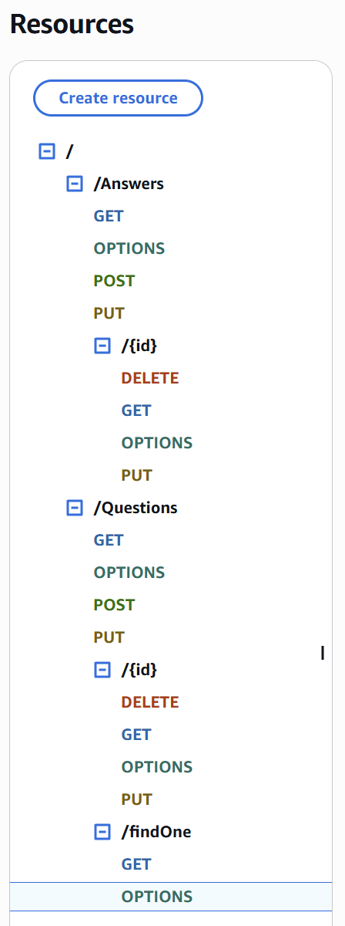

CORS Headers for the Other Methods

The other methods must return CORS headers as well. The good news is there is nothing for you to do now. Because you configured the APIs as proxies to the Lambdas, you can handle this in the Lambda code, which you have already done. Near the start of each Lambda you created in Module Five is the following code:

const responseHeaders = {
// HTTP headers to pass back to the client
"Content-Type": "application/json",
// the next headers support CORS
"X-Requested-With": "*",
"Access-Control-Allow-Headers":
"Content-Type,X-Amz-Date,Authorization,X-Api-Key,x-requested-with",
"Access-Control-Allow-Origin": "*",
"Access-Control-Allow-Methods": "OPTIONS,*",
// for proxies
Vary: "Origin",
// the "has-cors" library used by the Angular application wants this set
"Access-Control-Allow-Credentials": "true",
};

Toward the bottom of the Lambda is the code where the response to the client is created. You had this line of code:

// HTTP headers to pass back to the client
headers: responseHeaders,

Between these two blocks of code and the APIs being configured as proxies, you are handling the CORS requirements for the other methods.

Deployment

- Deploy the API using the “api” deployment name by clicking the Deploy API button in the top right of the API resource page.

Note: If your Deploy API button is greyed out, click out to the APIs list then back in to your API in development. The Deploy API button will be available again.

- Select *New stage* from the Stage drop-down menu.

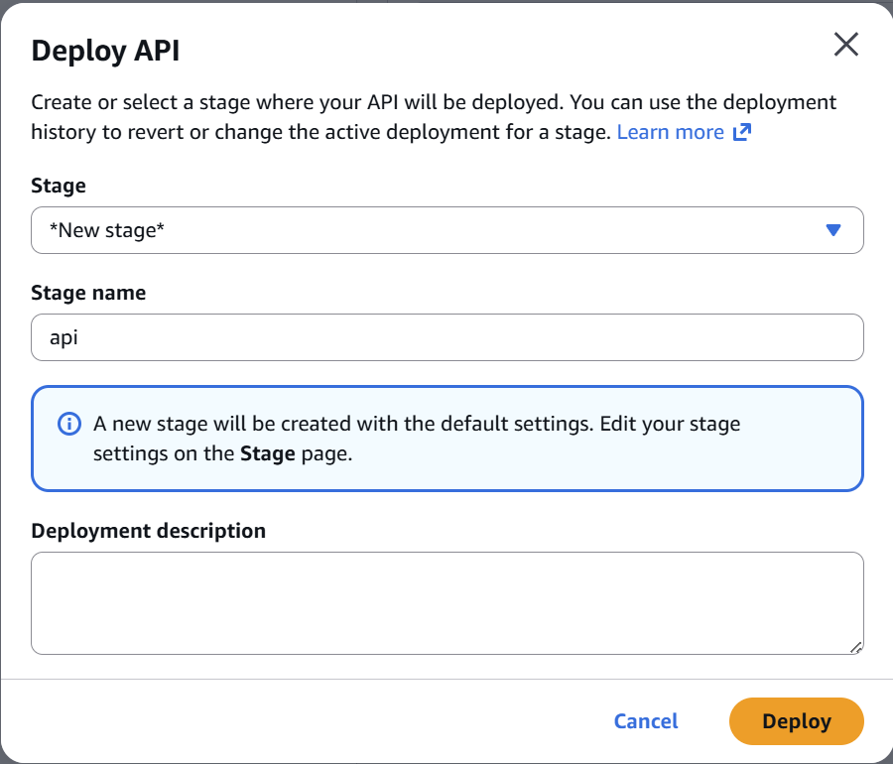

- Enter “api” as the Stage name and click Deploy.

Note: A common error at this stage is No integration defined for method. If you see this error, you forgot to click the Save button when mapping API methods to your Lambdas. Check each API method and fix it as needed. Then try again.

- Record the Invoke URL displayed after deployment. It will look like this:

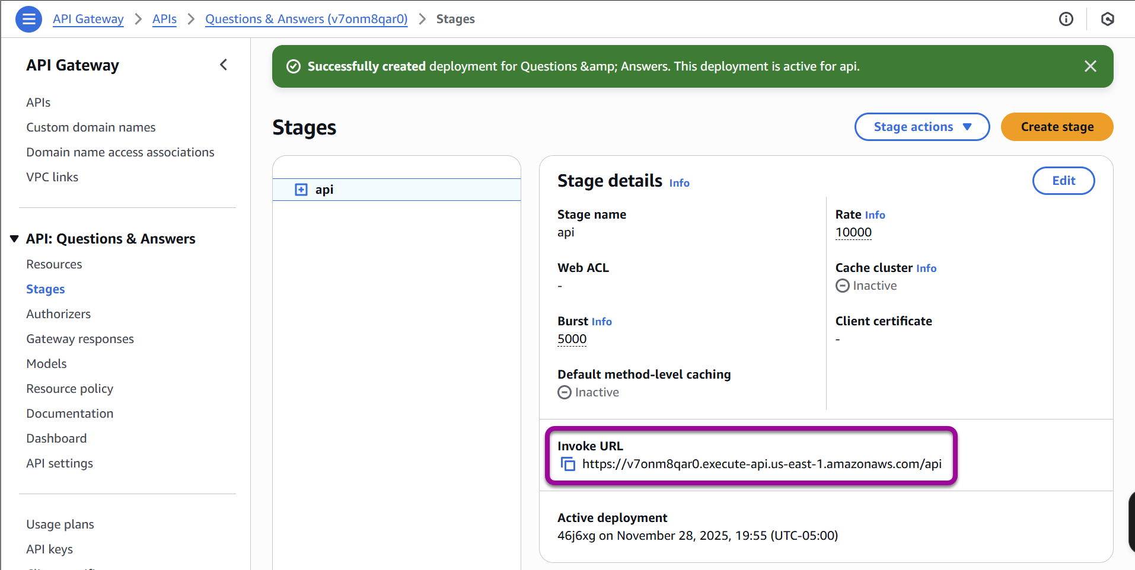

Modifying the Angular Application

- Modify main.ts from your lafs-web > src folder cloned from module two. Add the line LoopBackConfig.filterOnUrl(); to the end of the file. The resulting change will look like this:

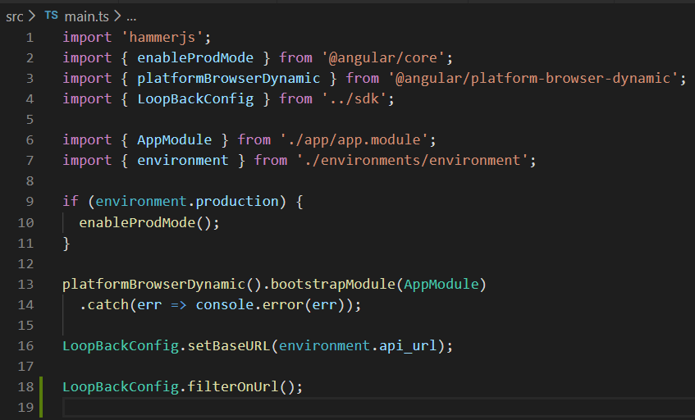

- Modify environment.prod.ts from your lafs-web > src > environments folder cloned from module two. Change the line api_url: 'https://q-a-example-loopback-api.herokuapp.com' to api_url: 'https://{deployed-url}.us-east-1.amazonaws.com' from the Invoke URL in the previous steps without the “/api”.

Remember: Your deployed URL is the one you created in the Deployment section of this guide. Do not include the ‘api’ or a trailing forward slash. The Angular application adds those.
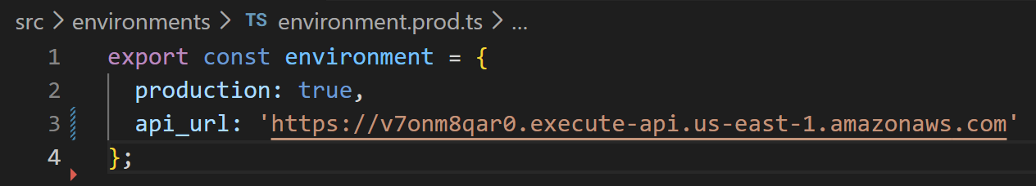

- Build and deploy the Angular application. See the Module Three Assignment Guide for a refresher.
    - Reminder: It may take several minutes for the build command to run before uploading the files to a new S3 bucket.
    - Optional: You can safely delete the existing elements in your existing S3 bucket before copying new files over if you choose in lieu of creating a new bucket with public security policy.

You Are Done!
Try testing your application. To explore your newly deployed application, navigate to your bucket website endpoint. On the landing page, click Angular. While you explore, consider the following notes:

- You shifted the application from using the LoopBack SDK on the client that was tied to the LoopBack REST API on the server.
- In completing the transfer, you would change the client side to not depend on the LoopBack SDK and its assumption of a LoopBack REST server.
- Why does this matter? When you add a new Question or Answer, the added text is not always seen right away. The call is successful. A new entry is visible, but the title is not.

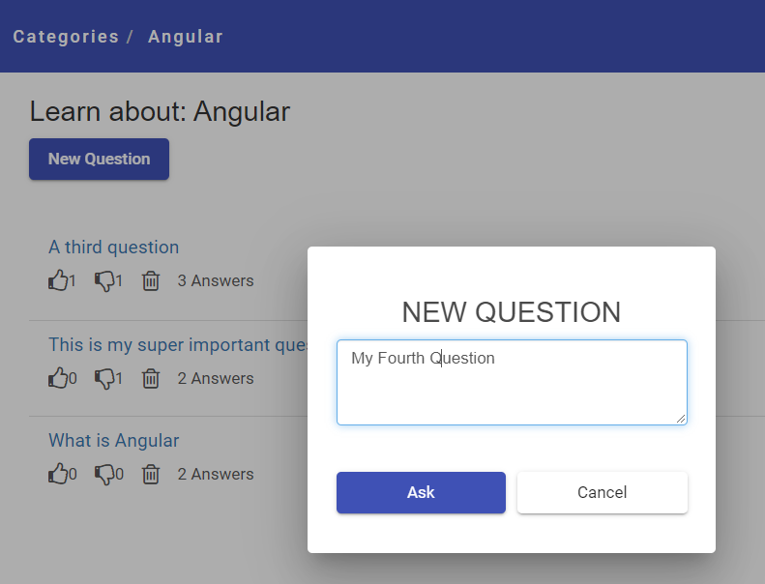

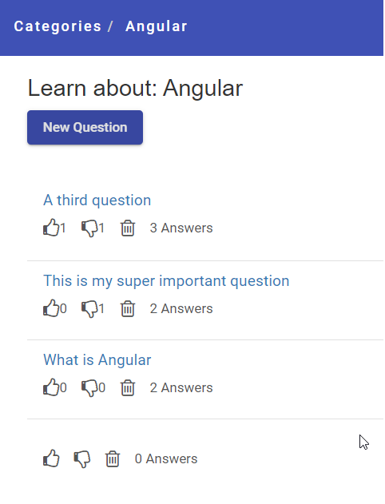

- If you click on Categories and go back into Angular, the new content will show up.

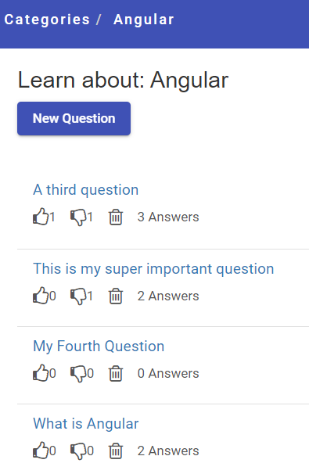

Changing this behavior may be beyond the scope of this class.

Time to celebrate a complete project!

